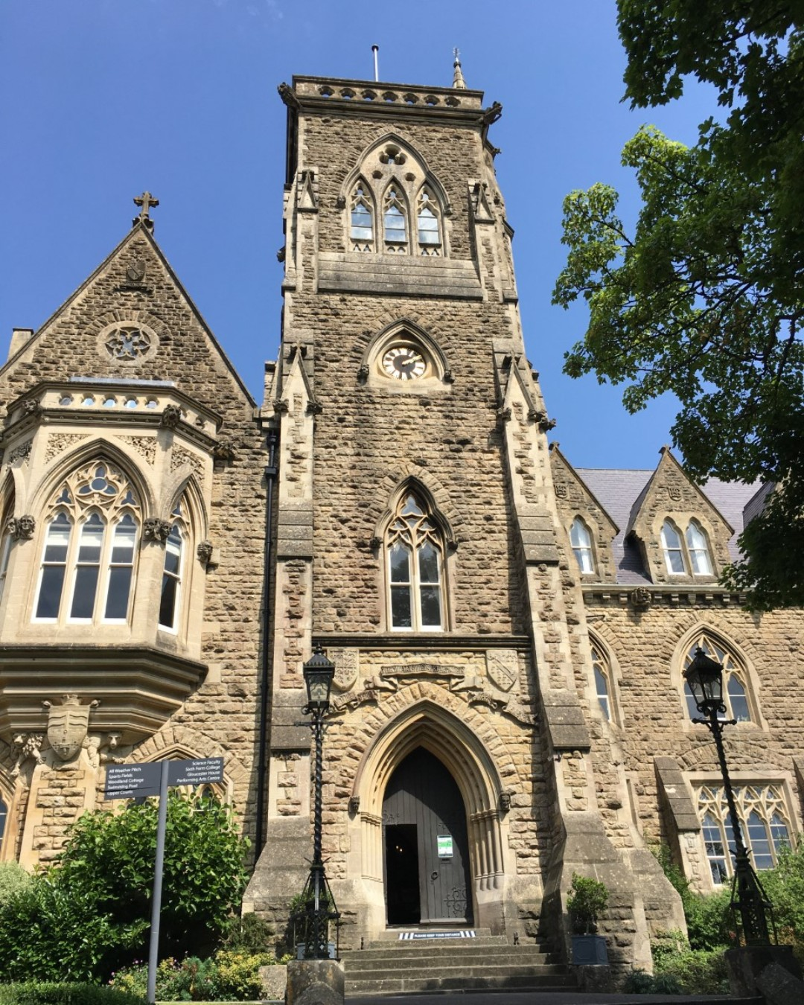

Holiday Club Assistant
Casual and Part Time Hours
Required from February 2022

Job Description

Role: Holiday Club Assistant

Accountable to: Prep Head

Job Purpose

Assist in the provision of day to day supervised care for children in the Holiday Club, providing a challenging environment which encourages the children’s all-round development. Work with others in ensuring that a continued high standard of care provisions is in place that meets the needs and aspirations of the school. Liaise with colleagues and where appropriate work on broader school issues/activities.

Accountabilities

- The following items are included in the professional duties, which a holiday club worker would be required to perform under the reasonable direction of the Head of Prep.
- Involvement in the design and running of sessions overseeing activities of children ensuring that they are undertaken in a safe and effective manner and that relevant school policies and procedures are adhered to.
- To establish good working relationships with staff, pupils and parents. On occasions act as first point of contact for parents to answer or refer enquiries providing accurate and timely responses to enquiries and other routine matters.
- To contribute to the planning and preparation of activities including the organisation & clearing of the facility at the end of the session
- To assist in the care, maintenance of toys and resources ensuring any faults or problems are reported.
- To assist in the preparation, serving & clearing away of snacks and packed lunches.
- To provide where appropriate basic first aid and record any incidents according to school policy and procedures.
- To communicate concerns, misbehaviour and information to the Holiday Club Coordinator and/or other staff as appropriate.
- To ensure children are handed over to parents/carers at the end of the day in accordance with school procedure.
- Undertake INSET and attend meetings as required.
- Cleaning of equipment and facilities.

General Requirements

All School staff are expected to:

- Work towards and support the School vision and the current School objectives outlined in the School Development Plan
- Contribute to the School’s programme of co-curricular activities
- Support and contribute to the School’s responsibility for safeguarding students

- Work within the School’s health and safety policy to ensure a safe working environment for staff, students and visitors
- Work within the GDST’s Diversity Policy to promote equality of opportunity for all students and staff, both current and prospective
- Maintain high professional standards of attendance, punctuality, appearance, conduct and positive, courteous relations with students, parents and colleagues
- Engage actively in the performance review process
- Adhere to policies as set out in the GDST Council Regulations, Notes of Guidance and GDST circulars
- Undertake any other reasonable duties required that are related to the job purpose from time to time.

Review and Amendment

This job description should be seen as enabling rather than restrictive and will be subject to regular review.

Safeguarding Checks

All appointments will be subject to two satisfactory reference, disclosure check by the Disclosure & Barring Service, medical fitness for this role and evidence of identity and qualifications. All the above checks must be completed before beginning work in the School. In the unlikely event of an unsatisfactory report being received following the issuing of a contract, the offer of appointment will be terminated without notice.

Person Specification

Skills Required
Basic level of numeracy & literacy | Essential
Organisational skills | Essential
Ability to communicate to a variety of groups from children to parents and senior managers | Essential
Work individually and as a member of a team | Essential
Solution focused and a flexible approach to work | Essential
Punctuality and good time management | Essential
The ability to play / organise basic games / sporting activities | Desirable
Creative Skills, Art and craft | Desirable
Knowledge Base
Proven experience of working with children aged 3 – 11 years of age  Understanding of Safeguarding | Essential
ICT literate | Essential
Qualifications/Attainment
Level 3 Childcare NVQ or equivalent | Essential
Paediatric First Aid Qualification | Desirable
Health & Safety procedures  Experience of a childcare / school setting | Desirable
Experience
Experience of planning and organising age appropriate activities | Desirable
Dealing with parents queries and issues providing solutions | Desirable
Attitude/Approach
Personal integrity, honesty, energy, stamina, enthusiasm | Essential
Professional appearance and manner | Essential
Develop positive relationships with staff, pupils and parents | Essential

Our School

Royal High School is an academically selective, independent day (3-18) and boarding (11-18) school for approximately 620 girls. Prep and Senior Schools are both situated on the northern side of Bath, enjoying commanding views of the city and with good access to the A46 and M4. 140 boarders aged 11-18 live on the senior site in two boarding houses. The Sixth Form is on the same site as the Senior School.

Committed to both academic excellence the School and outstanding care boasts excellent results at GCSE and post 16 level and there is demand for places. Sixth Form students choose between A level and the International Baccalaureate Diploma. Our latest Independent Schools Inspection report can be downloaded here:
https://www.royalhighbath.gdst.net/our-school/inspections

We are understandably proud of our facilities at the Senior School and Sixth Form, which contribute to the exceptional quality of care that we provide.

We have a stunning Art School; a Sixth Form café; a fitness suite, a Sixth Form building and newly refurbished boarding houses; two Performing Arts Theatres (Sophie Cameron Performing Arts Centre and The Memorial Hall); The Hudson Centre for lectures and meetings; tennis/netball courts and a newly refurbished astro and two well stocked libraries.

The school is accredited with the ICT Mark which recognises our commitment to using the latest digital platforms and channels to enhance learning. We introduced BYOD (Bring your Own Device) in September 2017.

The Prep School relocated in January 2014 to Cranwell House in Lower Weston which is a Grade II Victorian Mansion. The facilities offer first class opportunities to challenge and stimulate the girls with their learning. Within the main house, which is the base for our pupils from Nursery to Year 4, the girls have access to a ‘Discovery’ room, a creativity area and music practice rooms. The Hope Building (our stunning new build) houses the multi-purpose hall, creative arts and dance studios and the Year 5 and 6 classrooms. All girls throughout the school use their spacious, well-equipped classrooms alongside the beautiful grounds which offer enormous potential for outdoor learning and exploration.

Application Process

Please complete the online application form enclosing a letter to the Mrs Claire Lilley (Prep Head) supporting your application.

The deadline for applications is 17 January 2022.

For further information, please contact Miss Alice Pitt, HR Adviser, at hr@rhsb.gdst.net

Royal High School Bath
Lansdown Road
Bath
BA1 5SZ
Tel: +44 (0) 01225 313877
Website: http://www.royalhighbath.gdst.net

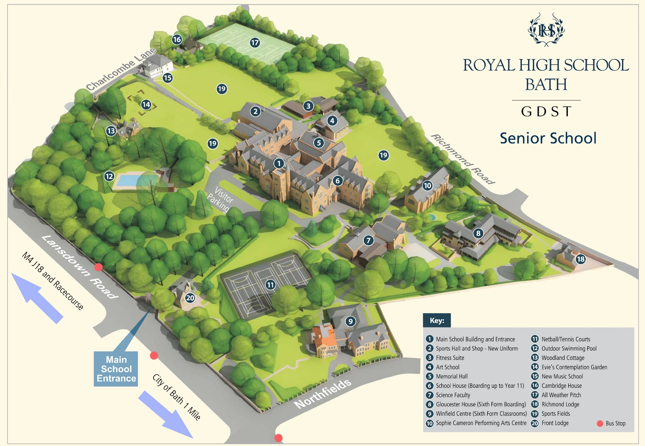
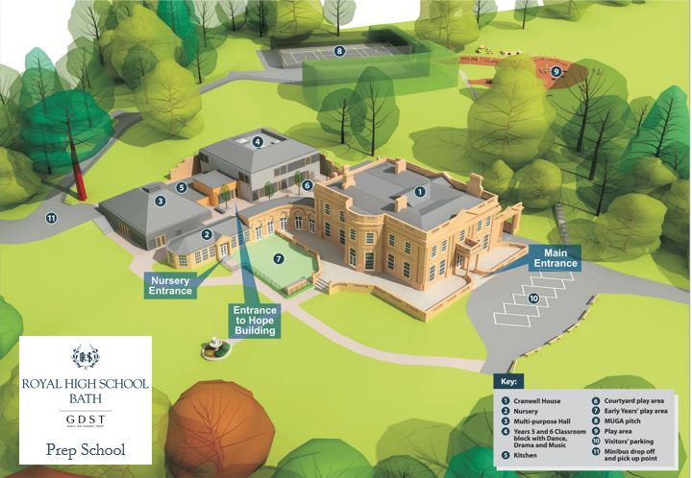

Royal High School Bath
Lansdown Road
Bath BA1 5SZ

Tel: +44 (0)12225 313877
Email: royalhigh@rhsb.gdst.net
Website: www.royalhighbath.gdst.net

